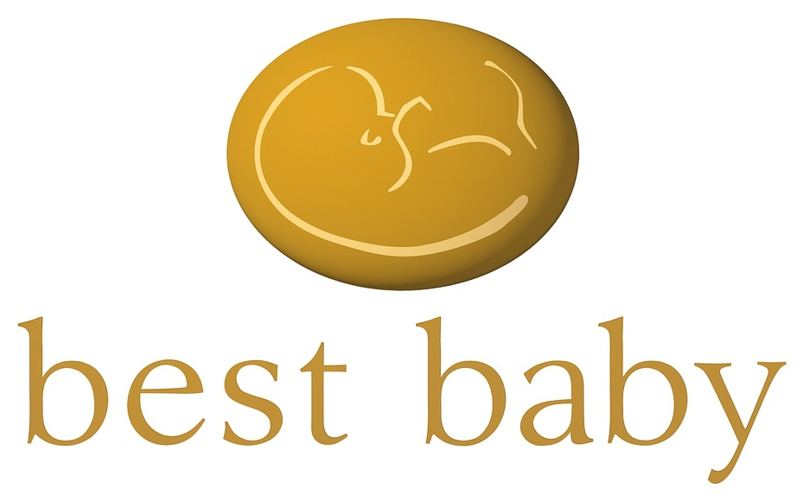
P R I V A T E B E T A
Basic Registration & Consent
Fields marked * are required.
EMAIL ADDRESS *
email@example.com — pre-filled and locked, cannot be edited
Your email address was saved when you entered the site.
About you
FIRST NAME * LAST NAME *
First name: Last name:
PREFERRED NAME *
What would you like Moira to call you?
The name Moira will use when talking with you. Can be a first name, nickname, anything.
POSTAL CODE *
e.g. EH1 1YZ
Helps us tailor content and guidance to where you are.
AGE CONFIRMATION *
☐ Yes, I confirm I am 18 or older.
You must confirm your age to create a BestBaby account.
ARE YOU A HEALTHCARE OR CHILDCARE PROFESSIONAL?
☐ Yes ☐ No
HOW DID YOU HEAR ABOUT BESTBABY?
☐ Invited ☐ A friend or family member ☐ Social media
☐ Search engine ☐ A healthcare professional ☐ Other
Collected solely to process your application and, if approved, to set up your account.…

Consent
Processing of Special Category Personal Data and Marketing
‘The next steps ask about your family and your journey. This is health-related information protected under UK data protection law. We need your permission before we collect it. Without this information, BestBaby will not know how to help you and will not be able to personalize your experience. It will not be used for marketing unless you separately agree below.
’Part 1 — Consent to processing of Special Category personal data

BestBaby.Org Ltd (‘BestBaby’) would like your consent to collect and use certain health-related and family information about you. Specifically, this covers information about where you are in your parenting journey — for example, whether you are trying to conceive, pregnant, preparing for birth, or in the early years with a child — and information about your family situation.
We will use this information to assess what information may be useful or of interest to you based on what you have told BestBaby and to provide this information to you. BestBaby will also use this information to provide services through the BestBaby Platform based on the personal data you have provided. We will also use this information to meet our obligations and exercise our rights under our agreement with you, including providing the information and guidance you request and administering your subscription.

Please see our Privacy Notice for full details of how we collect and use your data.
☐ I agree to BestBaby’s Terms of Use and have read the Privacy Notice. [insert link to Privacy Notice & Terms of Use]

This information is protected under UK data protection law as Special Category data. By providing the consent below, you are giving BestBaby explicit permission under UK GDPR Article 9(2)(a) to collect and use this information for the purpose described above.
☐ I consent to BestBaby collecting and using my journey and family situation information to personalise my BestBaby experience, as described above.
By ticking this box you are providing the consent required under UK data protection law (UK GDPR Article 9(2)(a)). This consent is equivalent to a standalone consent form and satisfies the same legal requirement.
You may withdraw this consent at any time by contacting BetaContact@BestBaby.org or updating your account settings. Without this consent BestBaby is unable to personalise your experience and registration cannot proceed.
Part 2 — Consent to marketing communications

You can register and use BestBaby without receiving marketing. It does not affect your access to any part of the platform.
BestBaby would like to send you relevant updates, recommendations, and curated offers by email or text message. Some of these may include products and services from carefully selected third-party partners from which BestBaby may earn a small commission. This is how we are able to keep BestBaby free.
BestBaby will not share your personal data with third parties for their own direct marketing purposes.
I consent to receiving relevant updates, recommendations, and curated offers about BestBaby by email and/or text message. I understand that some of these may include products and services about carefully selected third-party partners from which BestBaby may earn a small commission.
☐ Send me relevant updates, recommendations and curated offers by email.
☐ Send me relevant updates, recommendations and curated offers by text.
If you tick the text option, a field will appear for you to provide your mobile number. Your number is only collected if you opt in to text messages.
You can unsubscribe from marketing emails at any time by clicking the unsubscribe link in any email. You can opt out of text messages by replying STOP to any message or by contacting BetaContact@BestBaby.org. Withdrawing this consent does not affect your access to BestBaby.
Continue ☐
Continue is only active once the Part 1 consent box above is ticked. Part 2 marketing consent is optional and does not affect your ability to proceed.

BestBaby.Org Ltd | BetaContact@BestBaby.org | www.BestBaby.org

Continue →
Data written to the database on NR2 completion
— firstName — from this screen or pre-filled from Page 1B
— lastName — from this screen or pre-filled from Page 1B
— preferredName — always collected fresh on this screen
— postalCode — pending Lynn confirmation (see BTO flag above)
— ageConfirmed: true
— ageConfirmedAt: timestamp
— registrationCompleteAt: timestamp
BestBaby.org · BestBaby.Org Ltd · Registered in Scotland · SC899830
Internal review document — not for external distribution

